Activity
Fats: Chemistry and Identification-Model of a Phospholipid
Class Copy!!!
Background Information:
Fat molecules are also called lipids. Cell membranes and organelle membranes (like chloroplasts and mitochondria) are made of a certain kind of fat, or lipid, called phospholipid. It is a macromolecule that is made up of a glycerol molecule, 2 fatty acids and a phosphate molecule. It is this chemical structure that drives the “selectivity” of the cell membrane—in other words, why the cell membrane is semi-permeable.

Objectives:
In this investigation, you will
- Learn that all fat molecules are made up of two kinds of smaller molecules: glycerol and fatty acids.
- Use structural formulas and models of glycerol and fatty acids to determine how these molecules join to form fat molecules.

Materials:
Scissors
Paper models
Glue

Procedure
To better understand the chemistry of fats, it is helpful to study first the small molecules which join to make up fats. Phospholipid molecules are made up of 3 small “building blocks,:” or chemical molecules. These molecules are called Glycerol, Fatty Acids, and Phosphate

Questions about Glycerol (Answer all questions in your journal):
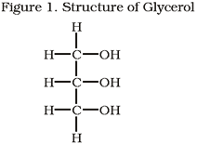
- What elements are present in Glycerol?
- What is the molecular formula for Glycerol? (add the number of
atoms of each element and record the totals.) C__H__O__
- Are there two times as many hydrogen atoms as oxygen atoms in
the Glycerol?
- If not, what is the ratio?
Fatty Acids:
The second kind of molecule, which is part of a fat, is a fatty acid. Many different fatty acids exist, but all are similar in several ways. Butyric Acid, Caproic Acid, and Lauric Acid are examples of fatty acids. Figures 2-4 shows the structural formulas for these three fatty acids.
Figure 2:

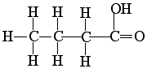
Butyric Acid
Figure 3:
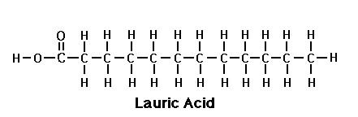

Examine the structural formulas for these three molecules.
Figure 4:
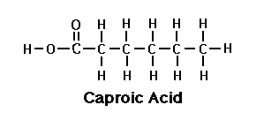
Questions about Fatty Acids:
- What elements are present in all fatty acids?
- What is the molecular formula for Butyric fatty
acid? C__H__O__

- What is the molecular formula for Caproic fatty acid? C__H__O__
- What is the molecular formula for Lauric fatty acid? C__H__O__
- How do the number of hydrogen atoms compare to the number of oxygen atoms in each fatty acid?
- How many oxygen atoms are present in each fatty acid?
Carboxyl Group:
O
II
H-O-C-

- Note the end of butyric acid containing the oxygen atoms. This special end arrangement of carbon, hydrogen and oxygen is call a carboxyl group. Is the carboxyl group present in all fatty acids shown?
- List a similarity between glycerol and fatty acids.
- Do fatty acids and glycerol both contain a carboxyl group?
Phosphate
A phosphate molecule is also part of the phospholipid molecule. It is where the “phopho” part of the word comes in.
Examine the structure below and answer the following questions:
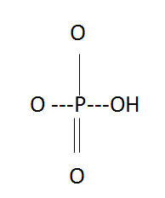
Questions about phosphates:
- How many phosphorous molecules are present in a phosphate molecule?
- How many oxygen molecules are present in an oxygen molecule?
- How many bonds do oxygen atoms usually have?
- Do the oxygen atoms in the phosphate molecule have the usual number of bonds?
- According to the phosphate structure, how many bonds does phosphorous make?

Combining Glycerol, Fatty Acids, and Phospholipids to Form Fats:
A phospholipid molecule consists of one glycerol molecule, 2 fatty acid molecules, and 1 phosphate molecule joined. Cut out the glycerol, fatty acid, and phosphate paper model molecules given to you by your teacher. Cut along the solid lines only.

Attempt to construct a fat molecule by fitting together pieces as if part of a puzzle. Remove three –OH ends from the glycerol molecule and two –H ends from the fatty acids and 1 –H end from the phosphate. Now join the molecules to form a fat. Glue your model onto your paper.
- How many glycerol molecules are needed to form a phospholipid molecule?
- How many fatty acid molecules are needed to form a phospholipid molecule?
- How many phosphate molecules are need to form a phospholipid molecule?
Join the leftover –H and –OH ends from your models. Glue these smaller models onto your paper
- What chemical substance is formed when the –H and –OH ends are joined?
Production of a fat molecule is chemical reaction. A chemical shorthand way of expressing the formation of a fat is as follows:
Glycerol + Fatty acid molecules + Phosphate Phospholipid (Fat) + Water Molecules
- How many water molecules are formed when one fat molecule is produced?
Many fats exist in living things. The wide variety of fats are formed by different combinations of fatty acid molecules.
- A change in the type of fatty acid results in a different type of a fat molecule. What molecule remains unchanged in all fats?

