ATP/ADP Energy Cycle Name __________________________________

Your cells require energy to carry out many different functions (active transport across the membrane, protein synthesis, and cell division). The fuel for these functions comes from a molecule called adenosine triphosphate (ATP). ATP stores energy until a cell needs it. When a cell requires energy, it breaks part of the ATP molecule apart which releases energy.

**Part 1: The structure of ATP**

ATP consists of 3 parts: 1 adenine molecule, 1 ribose sugar molecule, and 3 phosphate molecules. Energy is stored in the bond that is found between the 2nd and 3rd phosphate groups.

* COLOR & LABEL the following in the ATP molecules below: adenine – red, ribose – orange, 3 phosphate groups – yellow.
* 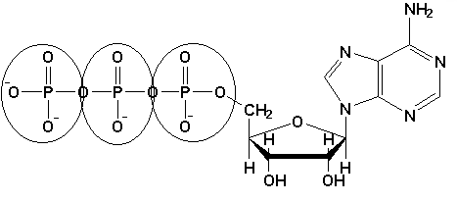Circle the area that represents the HIGH ENERGY bond.

**3**

**2**

**1**

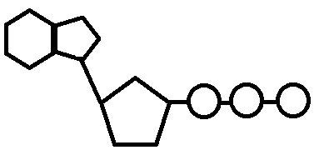

**1**

**2**

**3**

**Part 2: ATP Decomposition**

When a cell requires energy, it breaks off the last (3rd) phosphate group from the ATP molecule, which releases energy. The molecule that is left over is called adenosine diphosphate (ADP) which consists of adenine, ribose sugar, and **TWO** phosphate groups. ADP contains less energy than ATP.

* COLOR & LABEL the following in the energy molecule below: adenine – red, ribose – orange, first two phosphate groups – yellow, lone phosphate group – purple. COLOR the energy released – green.
* Circle the part of the image that makes up one molecule of ADP.

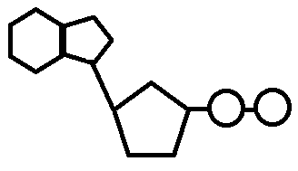

**ENERGY**

**RELEASED!**

**Part 3: ATP Synthesis**

ATP molecules are constantly being rebuilt from ADP and lone phosphate groups. This ensures that cells always have a source of energy. However, it takes energy to make ATP. The energy to make ATP comes from a carbohydrate called GLUCOSE. Glucose is a monosaccharide, or simple sugar. Its chemical formula is C6H12O6. Plants produce glucose during photosynthesis.

* COLOR & LABEL the following in the energy molecule below: adenine – red, ribose – orange, first two phosphate groups – yellow, lone phosphate group – purple. COLOR the energy absorbed – blue.
* Is the ENTIRE energy molecule called ATP or ADP? Be sure to LABEL the name below!

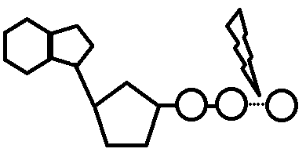

ENERGY Absorbed

1. (T/F) Organisms need a constant supply of energy to survive.
2. What is the structural difference between ATP and ADP? Compare/contrast structure of ATP & ADP.
3. Which structure, ATP or ADP, contains more stored energy? Where is the energy stored?
4. Which type of macromolecule (protein, carb, nucleic acid, or lipid) is ATP & ADP?

**Part 4: ATP/ADP Cycle** 🡪 SEE CUT OUTS ON NEXT PAGE

* Label ATP and ADP molecules
* Label Adenine, Ribose, Phosphate Groups (1, 2, 3) 🡪 both on the ATP & ADP molecule
* Color entire ATP 🡪 GREEN
* Color Energy Released 🡪 ORANGE
* Color Lightning Bolt 🡪 PURPLE
* Color Lone Phosphate in ADP 🡪 YELLOW
* Color entire ADP 🡪 BLUE
* Color Energy Absorbed 🡪 RED
* Cut all 5 images and rearrange them in your lab notebook showing the ATP/ADP cycle. Start with ATP on the top of the worksheet. Glue the images and then ADD ARROWS to show that this process is a continuous cycle. Give the cycle a title: **ATP/ADP Cycle**



\

