How Does Acid Affect Shells?
Vinegar is a solution of acetic acid. Mix vinegar and water in 5 beakers. Put only water in one beaker, only vinegar in another beaker, and mixtures of varying concentrations in the other beakers. Label each beaker with its contents and the concentration of vinegar (if appropriate).
1. | Place 6 to 10 crushed pieces of egg shells in each beaker. (or shells, if present)
2. | Wait one day. Then pour out the liquid from each beaker, and place the egg shell pieces on a paper towel. Examine the egg shell pieces.
Analyze and Conclude
- Use the chart below to record your observations.
Amount of Vinegar | Description after 0 minutes | Description after 10 minutes | Description after a day
- Egg shells and shells are made of calcium carbonate. How could ocean acidification affect corals, lobsters, snails, and other marine organisms that also have skeletons or shells made of calcium carbonate?

- How could ocean acidification become a severe problem? Use evidence and logical reasoning to support your answer.

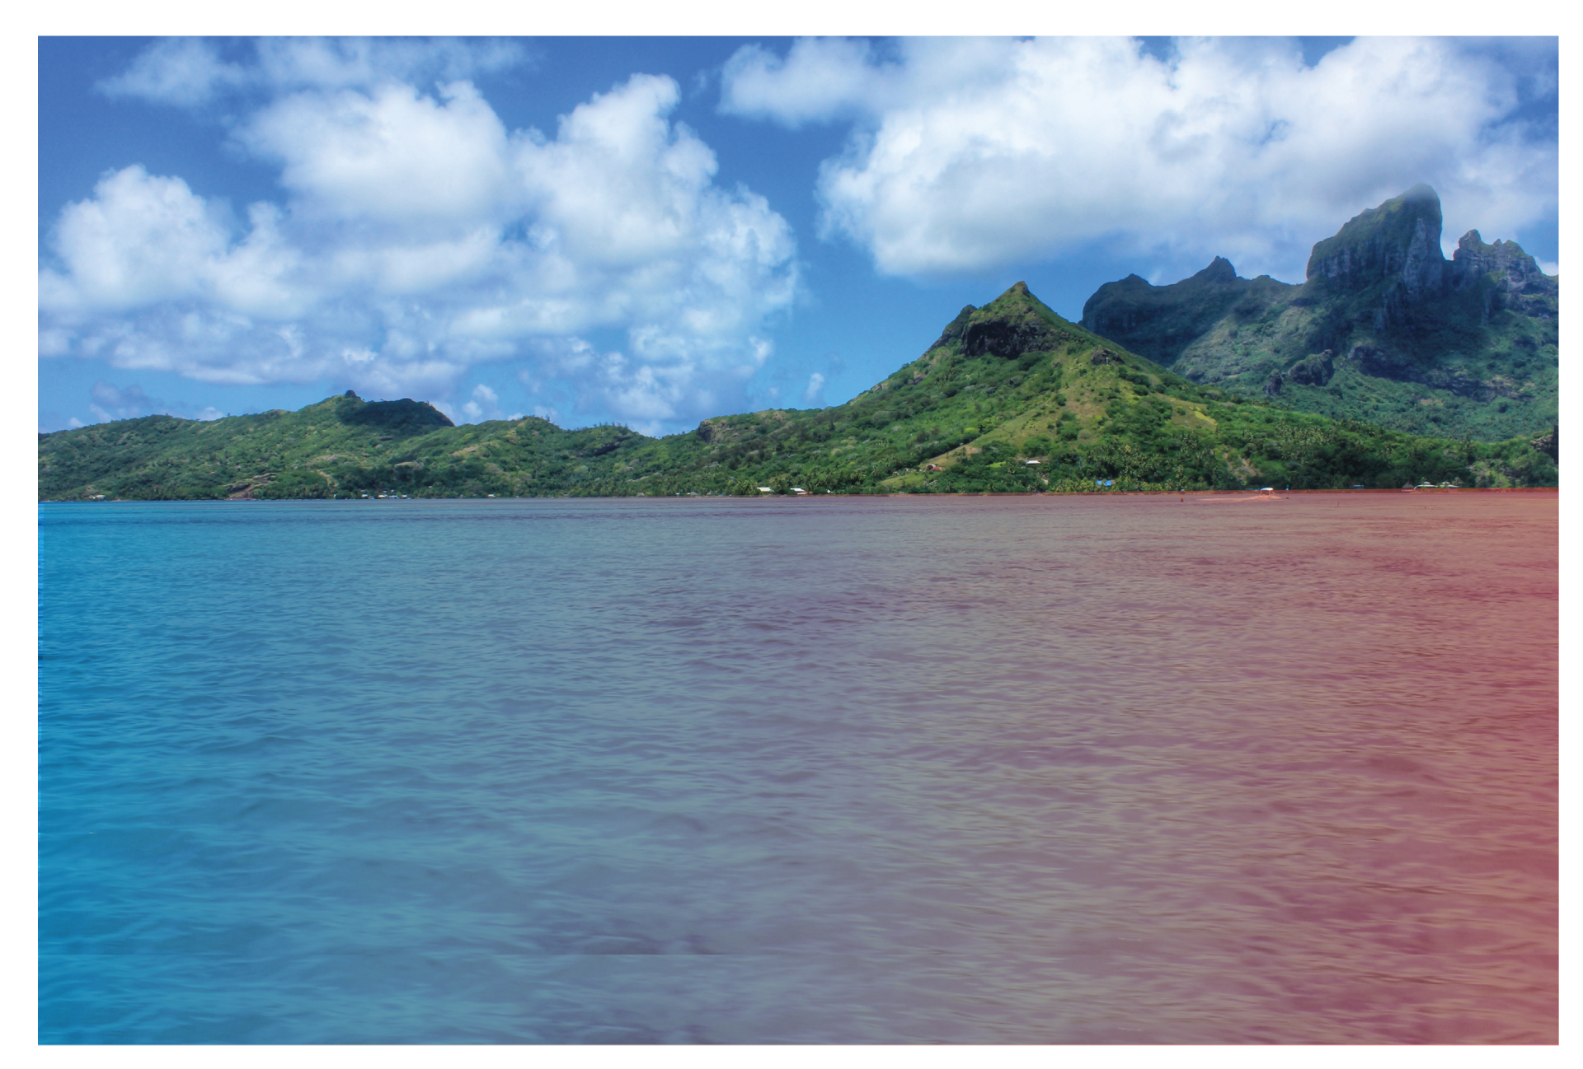
Ocean Acidification


