

Cell Transport in Plants

This activity can be found in your digital course.

Go to Classlink → Pearson Realize → Biology Book → Chapter 8 → Lesson 3

Click on Science Skills Activity: Cell Transport in Plants

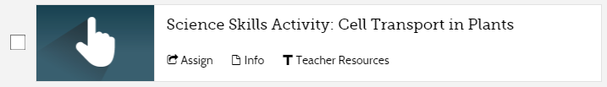
Vocabulary:
Salinity/Salinization: the amount of salt in something. High salinity means a lot of salt.
Concentration: the amount of a substance within another substance. Ex: salt concentration means amount of salt suspended in water. Similar to percent
Germinate: to sprout, or start growing
Crop yield: amount of a crop grown
Osmotic Balance: water pressure
Salt Tolerance: Ability to resist dying from salt concentrations
Irrigated: Watered
Problem Question: How does high salt concentrations in soil affect plant growth?

Record Data and Observations you will have to enter answers both online and on this paper: the online answers will let you move to the next page, but I will only stamp the answers on this paper

Part 1

- Why do some croplands suffer from excessive soil salinity?

Part 2

- From the Notebook Complete the following table summarizing the effects of salinity on plant growth or paste a copy of the completed table from the notebook in the virtual activity.

Electrical Conductivity of the Solution (dS/m) | Whole Plant Mass (g) | Number of Pods | Mass of Beans (g)
0
4
8
12

- Adding salt to water increases the ability of the saltwater solution to conduct electricity. dS/m is a measure of electrical conductivity. Does a 2 dS/m saltwater solution have more or less salt dissolved than a 10 dS/m saltwater solution?

Part 3
- Summarize the differences between how the salt-sensitive plant cell and the salt-resistant plant cell behave in the 10% salt solution.

Analyze and Conclude

- From the Notebook One of the symptoms of high salt concentrations in soil is plants that appear dehydrated even when they are receiving adequate water. How can you explain this phenomena using what you observed in the root cells of the salt-sensitive plants?

- Apply Concepts Suppose a farmer has contacted you for advice on how to avoid and manage problems related to soil salinity. What advice would you provide to the farmer?

- Evaluate a Solution Most fields that are irrigated year after year will eventually build up salt in the soil as water regularly evaporates and leaves some salt behind. One way farmers minimize this salt build up is to flood their fields every few years before planting. This flood water leaches out the salt in the soil. What advantages and disadvantages do you see in this approach?

