Characteristics of Life: Organism Project
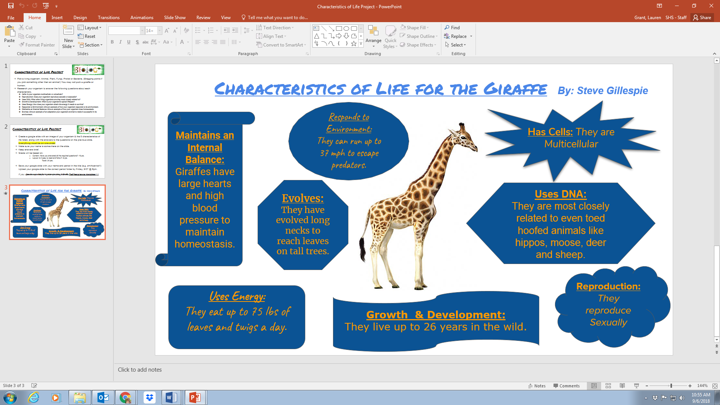
EXAMPLE: DO NOT COPY. You may not use the giraffe!
- Pick an organism:
  - Animal,
  - Plant,
  - Fungi,
  - Protista
  - Bacteria.
(Bragging points if you pick something other than an animal!) You may not pick a giraffe or human.
- Research your organism to answer the following questions about each characteristic.
  - Cells: Is your organism multicellular or unicellular?
  - Reproduction: Does your organism reproduce sexually or asexually?
  - Uses DNA: What other living organisms are they most closely related to?
  - Growth & Development: What is your organism’s typical lifespan?
  - Uses Energy: How does your organism obtain the energy it needs to survive?
  - Responds to Environment: Give an example of how your organism responds to its environment.
  - Maintains an Internal Balance: Give an example of how your organism does homeostasis.
  - Evolves: Give an example of an adaptation your organism evolved to make it successful in its environment.
- Create a mini poster on a 8.5/11 piece of paper to display this information
  - Use one page only
  - Include a drawing or picture of the organism
  - Write out what each characteristic is, and briefly describe how the creature demonstrates it.
  - You may type out these descriptions and glue them in, or hand-write them

