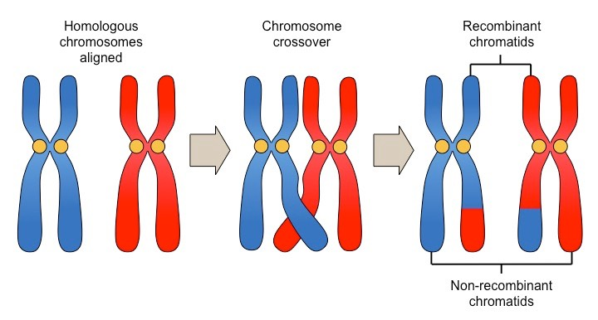
Crossing Over in Chromosomes
Blue: dad Red: mom
One gene (section of chromosome) being swapped

Crossing over: During meiosis, the genes on the two DNA strands in each chromosome “cross over” and switch genes. That means that the final replicated chromosomes that go through meiosis are actually each a combo of mom and dad’s genes!

Below is ONE set of homologous chromosomes: one from mom and one from dad. You are going to use these chromosomes to illustrate crossing over during meiosis.

- Color each chromosome a different color
- Cut out the entire replicated chromosome. DO NOT SEPARATE THE DNA STRANDS
- Form a homologous pair and cross over!
  - Stack the chromosomes, one on top of the other
  - Cut and switch genes (with the same letter, but maybe different capitalization) between mom and dad for any genes you choose
  - Be sure to switch the same DNA strand (left or right) from mom and dad!
- Create your gametes in your journal/sheet of paper/document!
  - Either make 4 sperm or one egg and 3 extras (called polar bodies).
  - This means glue in the chromosome, and draw the gamete around it. Or, copy and past the chromosomes into a word document and draw around them
- Using Ms. Grant’s Key, figure out what genes the gametes will pass on!
- Write the final traits the gamete will pass on into your journal/sheet of paper/document!

Key:

A= brown hair
a= blonde hair

B=Brown Eyes
b=blue eyes

C= free earlobes
c= attached earlobes

D= normal hearing
d= deafness

Chromosome Cut-Outs!

Left DNA strand: dashed line
Right DNA strand: Solid line

D

D

C

d

c

c

D

C

b

b

A

A
B

B

a

a

Chromosome from mom
Color one solid color
Chromosome from dad
Color one solid color (different color)

