Monster Genetics Worksheet
Complete this FIRST, to determine your monster’s genes and traits!

Hair color Gene
DNA: _ _ _ - _ _ _ - _ _ _ - _ _ _ - _ _ _ - _ _ _ - _ _ _ - _ _ _ - _ _ _ - _ _ _
mRNA: _ _ _ - _ _ _ - _ _ _ - _ _ _ - _ _ _ - _ _ _ - _ _ _ - _ _ _ - _ _ _ - _ _ _
Amino Acid Sequence:

Trait:

Leg Gene
DNA: _ _ _ - _ _ _ - _ _ _ - _ _ _ - _ _ _ - _ _ _ - _ _ _ - _ _ _ - _ _ _ - _ _ _
mRNA: _ _ _ - _ _ _ - _ _ _ - _ _ _ - _ _ _ - _ _ _ - _ _ _ - _ _ _ - _ _ _ - _ _ _
Amino Acid Sequence:

Trait:

Skin Gene
DNA: _ _ _ - _ _ _ - _ _ _ - _ _ _ - _ _ _ - _ _ _ - _ _ _ - _ _ _ - _ _ _ - _ _ _
mRNA: _ _ _ - _ _ _ - _ _ _ - _ _ _ - _ _ _ - _ _ _ - _ _ _ - _ _ _ - _ _ _ - _ _ _
Amino Acid Sequence:

Trait:

Eyes Gene
DNA: _ _ _ - _ _ _ - _ _ _ - _ _ _ - _ _ _ - _ _ _ - _ _ _ - _ _ _ - _ _ _ - _ _ _
mRNA: _ _ _ - _ _ _ - _ _ _ - _ _ _ - _ _ _ - _ _ _ - _ _ _ - _ _ _ - _ _ _ - _ _ _
Amino Acid Sequence:

Trait:

Hair Texture Gene
DNA: _ _ _ - _ _ _ - _ _ _ - _ _ _ - _ _ _ - _ _ _ - _ _ _ - _ _ _ - _ _ _ - _ _ _
mRNA: _ _ _ - _ _ _ - _ _ _ - _ _ _ - _ _ _ - _ _ _ - _ _ _ - _ _ _ - _ _ _ - _ _ _
Amino Acid Sequence:

Trait:

Special Feature Gene
DNA: _ _ _ - _ _ _ - _ _ _ - _ _ _ - _ _ _ - _ _ _ - _ _ _ - _ _ _ - _ _ _ - _ _ _
mRNA: _ _ _ - _ _ _ - _ _ _ - _ _ _ - _ _ _ - _ _ _ - _ _ _ - _ _ _ - _ _ _ - _ _ _
Amino Acid Sequence:

Trait:

Arms Gene
DNA: _ _ _ - _ _ _ - _ _ _ - _ _ _ - _ _ _ - _ _ _ - _ _ _ - _ _ _ - _ _ _ - _ _ _ -_ _ _ - _ _ _
mRNA: _ _ _ - _ _ _ - _ _ _ - _ _ _ - _ _ _ - _ _ _ - _ _ _ - _ _ _ - _ _ _ - _ _ _ -_ _ _ - _ _ _
Amino Acid Sequence:

Trait:

Answer the problem questions and draw your monster based on what you determined above!
Problem Questions:

- What does the DNA sequence of a chromosome determine?

- Explain how the amino acid sequence determines the characteristics of an organism.

- If there is a change in the DNA sequence, what are the possible outcomes? Explain and justify your answer.

- Explain how the DNA sequence in your monster is similar to your DNA sequences. Justify your answer.

- If the monster has a mutation and a base is inserted after the third base in the hair gene, predict the result

Draw your Monster IN COLOR
As a reminder, I am posting a slide show of these! (unless you abstain, and ask me not to)
Monster’s Name:
Your name:
Permission to post?

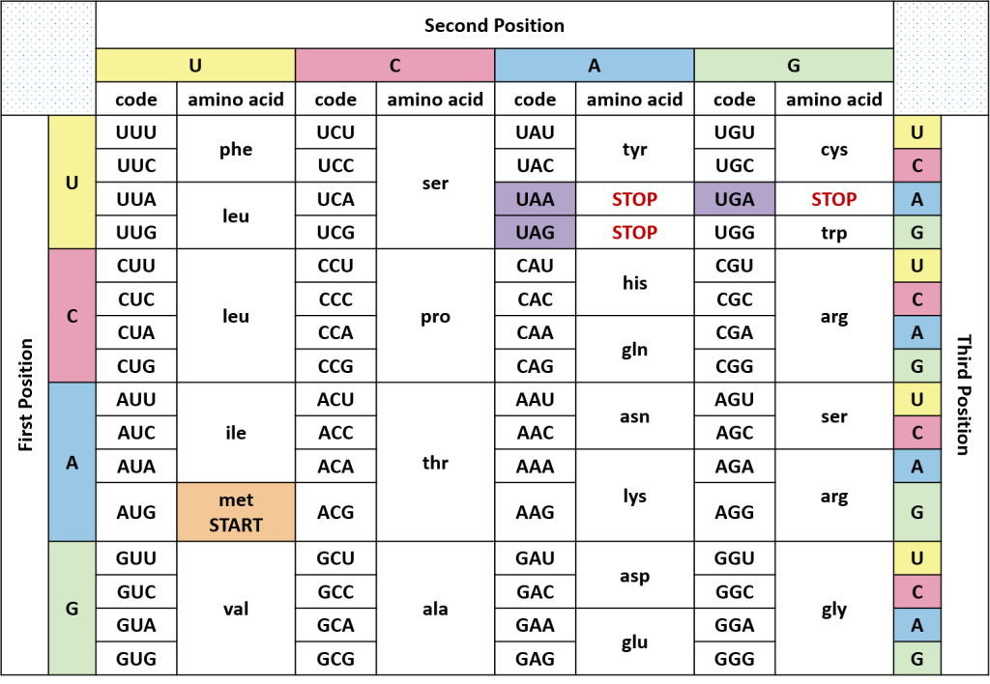
Codon Chart: Read the mRNA Codon (1st letter, 2nd letter, 3rd letter) to find the Amino Acid

