|  |
| --- |
| http://www.nearctica.com/nathist/amphib/Frog.GIFScientific Process |

#### Sample lab, use the diagram below to complete all the parts of a formal lab write-up.

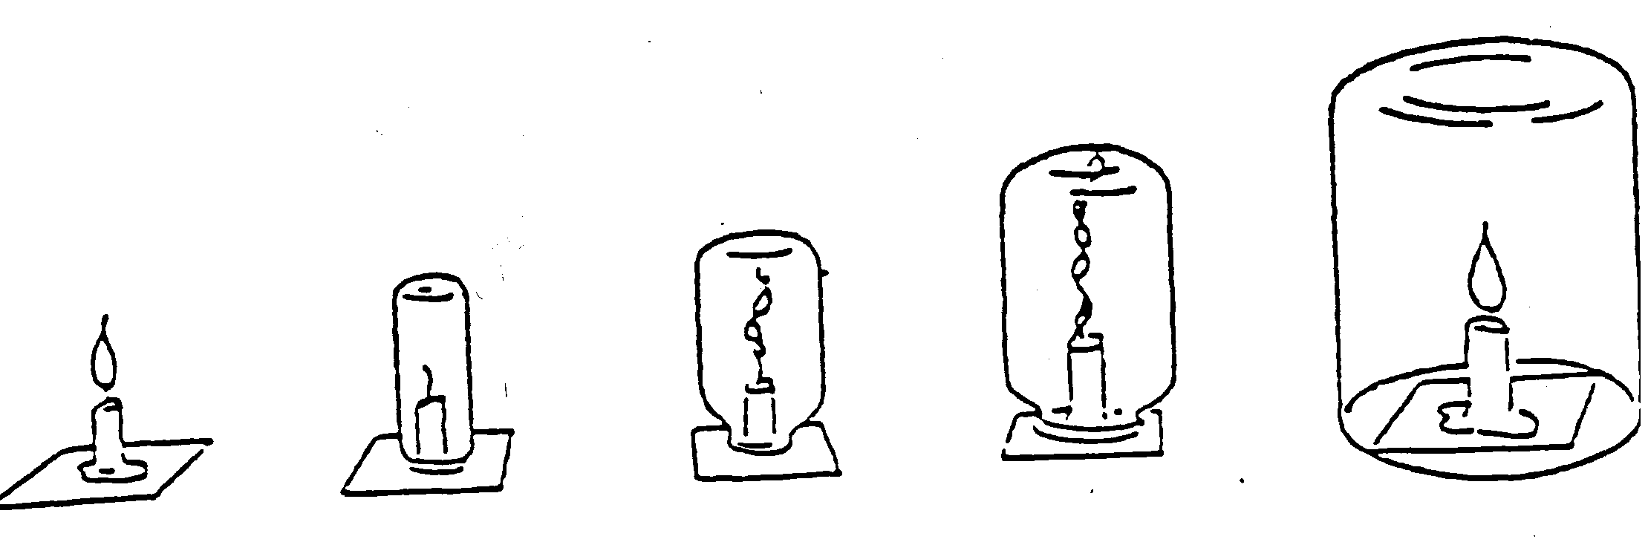

1. **Problem statement:**

**_____________________________________________________________________________________**

1. **Hypothesis:**

**_____________________________________________________________________________________**

**_____________________________________________________________________________________**

1. **Identify the variables:**

**Manipulated: ______________________________________________________________________**

**Responding: ______________________________________________________________________**

**Control variables: _____________________________________________________________________**

#### Identify the Groups:

____________________________________________________________________________________

**____________________________________________________________________________________**

**____________________________________________________________________________________**

#### Materials and Apparatus list:

1. **Procedures**:
2. **Data Collection:**



1. **Data Analysis:**

**_______________________________________**

_______________________________________

**_______________________________________**

**_______________________________________**

**_______________________________________**

**_______________________________________**

1. **Conclusion**:

**____________________________________________________________________________________**

**____________________________________________________________________________________**

**____________________________________________________________________________________**

**____________________________________________________________________________________**

**____________________________________________________________________________________**